COURSE SYLLABUS ALGEBRA II

INSTRUCTOR: Christy Freeman
TEXT: Algebra II by BJU Press, 2nd edition. You must buy the second edition!
If you check with me, I may have some used copies available for purchase. They are also easily found used on the internet, especially Amazon. Students should have their books at the first class.

EMAIL/PHONE: christy@rrfarm.org, (813) 318-1008 (call or text)
Students will also be able to message me through our grading system.

OBJECTIVE
The objective of this course is to complete a study of Algebra II topics. These include, but are not limited to, the structure of the real number system with an extension into the complex number system, a careful study of mathematical functions (constant, linear, quadratic, rational, logarithmic, exponential), a reinforcement of the connection between algebra and geometry, sequences and series, right triangle trigonometry, and permutations, combinations and probability.

CLASS FEE:
Students will be asked to pay a $25.00 fee to cover all copies of notes, quizzes, tests and assignment sheets. Checks or cash are due at the first class. Checks should be made payable to Christy Freeman. (NOT Class Source!)

CLASS REQUIREMENTS:
    - The student is expected to complete all assigned homework problems, quizzes and tests and turn them in on time.
    - The student is expected to participate in class discussions and activities.
    - The student is expected to bring all notes, textbook, pencil, and paper to every class.

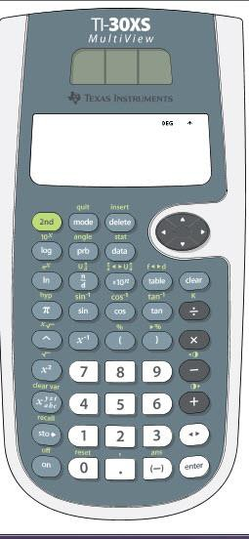
GRADES:
50% Homework 50% Tests and Quizzes

Incomplete/Late Assignments
Students are expected to bring completed assignments to class each week. Late assignments will not be accepted unless parents contact the instructor to make other arrangements.

Materials required: In addition to the textbook, students should have a three ring binder, graph paper, notebook paper, a ruler, and a TI-30XS MULTIVIEW calculator. It is about $15 on Amazon and about $17 at Staples. If you have another calculator and want to use it, please discuss it with me. Graphing calculators are also acceptable if you already own one, but are not required.

GRADING SCALE
90-100 =A, 80-89=B, 70-79=C, 60-69=D, 50-59=F

